**VISVESVARAYA TECHNOLOGICAL UNIVERSITY BELAGAVI, KARNATAKA**



*A Mini Project Report*

***(Fifth Semester)***

*on*

**COLLEGE TIME TABLE GENERATOR**

*Submitted in the partial fulfillment for the requirements for the conferment of degree of*

**BACHELOR OF ENGINEERING**

in

**INFORMATION SCIENCE AND ENGINEERING**

By

**Mr. Ajay V Kamath** USN: 1BY20IS016

**Mr. Abhishek Shankar** USN: 1BY20IS009

**Mr. Akanksh P N** USN: 1BY20IS017

Under the guidance of

**Dr. Drakshaveni G**

Assistant Professor Dept. of ISE



**BMS INSTITUTE OF TECHNOLOGY & MANAGEMENT**

### YELAHANKA, BENGALURU-560064

**DEPARTMENT OF INFORMATION SCIENCE & ENGINEERING**



**CERTIFICATE**

This is to certify that the Mini Project (Fifth Semester) entitled **“COLLEGE TIME TABLE GENERATOR”** is a bonafide work carried out by **Mr. Ajay V Kamath (1BY20IS016),** **Mr. Abhishek Shankar (1BY20IS009)** and **Mr. Akanksh PN (1BY20IS017)** in partial fulfillment for the award of **Bachelor of Engineering Degree in Information Science and Engineering** of the Visvesvaraya Technological University, Belagavi during the year 2022-2023 It is certified that all corrections/suggestions indicated for internal assessment have been incorporated in this report. The mini project report has been approved as it satisfies the academic requirements with respect to mini project work for the B.E Degree.

**Signature of the Guide Signature of the HOD**

## Dr. Drakshaveni G

**Examiner**

## Name Signature

1.

2.

# ACKNOWLEDGEMENT

We are happy to present this Mini Project after completing it successfully. This Mini Project would not have been possible without the guidance, assistance and suggestions of many individuals. We would like to express our deep sense of gratitude and indebtedness to each and every one who has helped us make this Mini Project a success.

We are grateful to **Dr. Mohan Babu G N,** Principal, BMS Institute of Technology & Management for his constant encouragement and support.

We heartily thankthe Head of the Department, Information Science and Engineering, for her constant encouragement and inspiration in taking up this project.

We gracefully thank our guide**, Dr. Drakshaveni G** Assistant Professor, Dept. of Information Science and Engineering, for her encouragement and advice throughout the course of this project work.

Nevertheless, we express our gratitude towards our family and friends for the encouragement and support which helped us to finish this project successfully.

By,

**Ajay V Kamath**

**Akanksh PN**

**Abhishek Shankar**

# DECLARATION

We, hereby declare that the Mini Project titled “COLLEGE TIME TABLE GENERATOR” is a record of original Mini Project work undertaken for the award of the degree of Bachelor of Engineering in Information Science and Engineering of the Visvesvaraya Technological University, Belagavi during the year 2022-23. We have completed this Mini Project work under the guidance of **Dr. Drakshaveni G,** Assistant professor, Dept. of ISE.

I also declare that this Mini Project report has not been submitted for the award of any degree, diploma, fellowship or other title anywhere else.

|  |  |
| --- | --- |
| **Student Photos:** |  |

Ajay V Kamath

Akanksh P N

Abhishek Shankar

# ABSTRACT

Most colleges have several different courses and each course consists of many subjects. Now there are limited faculties, each faculty teaching more than one subjects. So now the time table needed to schedule the faculty at provided time slots in such a way that their timings do not overlap and the time table schedule makes best use of all faculty subject demands.

Timetable scheduling is the process of creating timetables that fit the constraint of the scenario. University course timetabling is a NP-hard problem which is very difficult to solve by conventional methods. A highly constrained combinatorial problem, like the timetable, can be solved by evolutionary methods.

It has various applications ranging from scheduling transportations and college timetables to creating complex schedule for highly optimized automated factories. Majority of small-scale scheduling are done manually while larger operations require computer assisted scheduling.

Lot of problem-solving methods, which typically use the concept of customary optimization algorithms such as genetic algorithms, Backtracking, Constraint Logic Programming.

In recent years two major approaches appear to have been victorious.

• Local Search Procedures

• Constraint Programming (CP)

Newer methods like Genetic Algorithm, which mimics Natural Selection, and Tabu Search use Metaheuristic or Meta-strategy and Artificial Intelligence to solve the problem.

Automated timetabling has become subject to multiple advanced research and there exists even a conference named The International Series of Conferences on the Practice and Theory of Automated Timetabling (PATAT) which is held biennially to serve as a forum for an international community of researchers, practitioners and vendors on all aspects of computer-aided timetable generation.

Our project aims to achieve the goal of generating a time table by a simple algorithm with lesser constraints and more to do with our college requirements. It is aimed at systematically generating timetables for students as well as faculty.

TABLE OF CONTENTS

CHAPTER 1: INTRODUCTION 1

1.1 Outline: 1

1.2 Motivation and Scope: 1

1.3 Problem Statement: 1

1.4 Limitations: 2

CHAPTER 2: REQUIREMENT SPECIFICATIONS 3

2.1 Functional Requirements: 3

2.2 Non-Functional Requirements: 3

2.3 Domain Constraints: 4

CHAPTER 3: SYSTEM/REQUIREMENT ANALYSIS 5

3.1 Requirement Analysis: 5

3.2 System Analysis: 5

CHAPTER 4: SYSTEM DESIGN 7

4.1 Entity Relationship Diagram: 7

CHAPTER 5: IMPLEMENTATION 9

5.1 Description of Database Tool and Backend 9

5.2 Description of Implementation of Frontend 9

CHAPTER 6: TESTING 11

6.1 Component Tests: 11

6.2 System Test: 11

CHAPTER 7: INTERPRETATION OF RESULTS 13

CHAPTER 8: CONCLUSION 18

CHAPTER 9: REFERENCES 19

DEPARTMENT VISION & MISSION 20

CHAPTER 1: INTRODUCTION

### Outline:

A database is a collection of inter-related data which is used to retrieve, insert, and delete the data efficiently. It is also used to organize the data in the form of a table, schema, views, and reports, etc. Database management system is a software which is used to manage the database. For example: MySQL, Oracle, etc. are some very popular commercial database management systems.

DBMS provides an interface to perform various operations like database creation, storing data in it, updating data, creating a table in the database and a lot more. It provides protection and security to the database. In the case of multiple users, it also maintains data consistency.

The Time Table Generator is a database Management system that uses database technology to construct, maintain and manipulate various kinds of data about an educational institution. This data could then be used to generate time tables for all teachers as well as students. There may be several departments in the institution, which employ several lecturers.   
Most colleges have several different courses and each course has a number of subjects. Now there are limited faculties, each faculty teaching more than one subjects. So now the time table needed to schedule the faculty at provided time slots in such a way that their timings do not overlap and the time table schedule makes best use of all faculty subject demands.

### Motivation and Scope:

The motivation for a college time table generator project is to streamline the process of creating class schedules and to improve the efficiency and accuracy of the time table creation process. Manually creating a time table can be a time-consuming and error-prone process, and a software solution can help to significantly reduce the amount of time and effort required.

The scope of a college time table generator project may include the development of a software program that is able to generate a complete and accurate time table for a college or university. The program should be able to take into account the availability of classrooms, the schedules of professors, and the needs of different departments and programs. It should also be user-friendly and easy to use, with an intuitive interface that is accessible to users of all skill levels.

### Problem Statement:

The timetabling is a multi-dimensional assignment problem, in which students and lecturers are assigned to courses and events are assigned to classrooms that must not overlap. The events are usually meeting between people at a particular location. Our project aims at developing a solution to the timetabling problem at an institution level

### Limitations:

The scope of this project is currently limited to colleges. Further changes must be made in the code to accommodate custom constraints. One such constraint is that some courses like laboratories require 2 consecutive hours. This constraint has not been covered in the current version of the project since the objective was to develop only a simply application with basic constraints.

Another limitation of this project is that it does not schedule the timings of break in between working hours and it assumes all the working days to have some number of working hours.

CHAPTER 2: REQUIREMENT SPECIFICATIONS

### Functional Requirements:

**Unambiguous Time Table generation:**

* The project must output timetables for teachers as well as students that follow all the basic constraints of a time table.
* It should neither have empty slots nor overlapping schedules.

**View/Delete data:**

* The tables of the database must be displayed in a printable format when requested by user.
* The user must be able to delete previously entered information.

**Create/Update data:**

* The user must be able to initially create a database consisting of teachers’ details, their time tables, department information etc.
* The user must be able to update values of the same.

### Non-Functional Requirements:

**Performance**:

* + - Response time of the System should be minimal.
    - The application must not be resource heavy.

### Reliability:

* + - The system must not fail under unforeseen circumstances and must be robust.
    - Input validation must be done so that errors do not occur.

**Easy to use interface:**

* The application must have an easy to use and understand user interface.
* The GUI must be unambiguous.

### Security:

* + - The database may contain sensitive information like email ID, Phone numbers etc. This must be stored safely.
    - Unauthorized users or hackers must not be able to gain access to sensitive data.

### Domain Constraints:

Domain constraints are defined as the valid set of values of an attribute. In this project, we have used various domain constraints such as primary keys, foreign keys and restrictions on the type of data stored in the table. The tables use the VARCHAR Data type to store strings and text values like subject name, department name etc. INTEGER data type is used to store numeric values like semester, subject credits. Integrity constraints are also managed in this project. All the IDs that are used to identify entities like department ID, Teacher ID are set to PRIMARY KEY. These entities act as Foreign Keys in other tables and help in connecting tables. All the data has been normalized for convenience.

* 1. **Software Requirements**
* Operating System: Windows/Linux/MacOS
* Web Browser with HTML5 support
* Python: version 3.7 or higher
* MySQL: version 8 or higher
* MySQL Python Connector
  1. **Hardware Requirements**
     + Processor: Intel i5/AMD Ryzen 5 or higher
     + RAM: 8GB or more
     + At least 3GB free disk space

CHAPTER 3: SYSTEM/REQUIREMENT ANALYSIS

### Requirement Analysis:

A requirement analysis for a college time table generator project would involve identifying and documenting the specific needs and requirements for the software. This may include determining the goals and objectives of the project, as well as the specific features and functionality that the time table generator should have.

Some potential requirements for the time table generator project may include:

* The ability to generate a complete and accurate time table for a college or university
* The ability to consider the availability of classrooms, the schedules of professors, and the needs of different departments and programs
* A user-friendly and intuitive interface
* Compatibility with different devices and platforms
* The ability to handle a wide range of inputs and constraints
* The ability to import and export data in different formats
* Security and data privacy features
* Support for multiple languages

Conducting a thorough requirement analysis is an important step in the development of any software project, as it helps to ensure that the final product meets the needs and expectations of the users.

### System Analysis:

System analysis for a college time table generator project would involve analysing the current process for creating class schedules at the college or university and identifying areas for improvement. This may include examining the current time table creation process, the tools and resources that are used, and the challenges and problems that are encountered.

The system analysis that we performed involved researching and evaluating different software solutions that are available to create class schedules. This may include considering the features and functionality of different software options, as well as the costs and benefits of each option.

The goal of the system analysis is to identify the best solution for creating class schedules that meets the needs and goals of the college or university. This involves developing a custom time table generator software program.

We considered the technical requirements for the time table generator, such as the hardware and software platforms that it will be used on, as well as any data storage and security needs. We identified any additional resources or support that will be needed to implement and maintain the time table generator. All this has been mentioned in the requirements section of this report.

CHAPTER 4: SYSTEM DESIGN

### Entity Relationship Diagram:

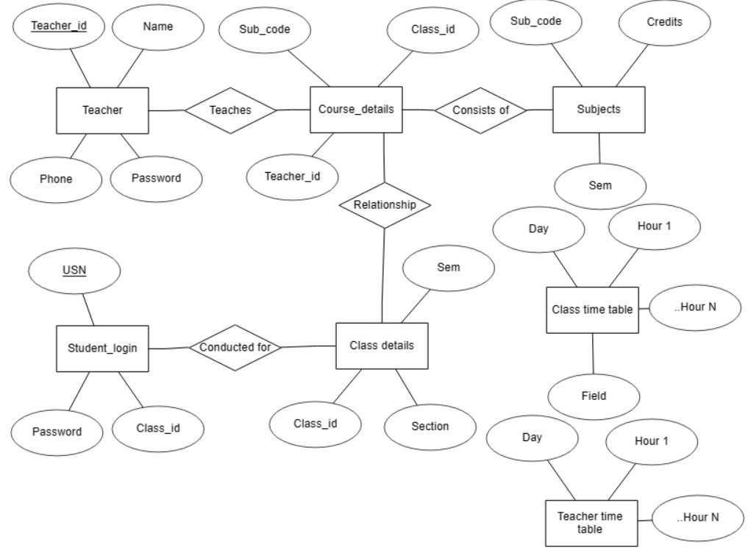

**Schema Diagram:**

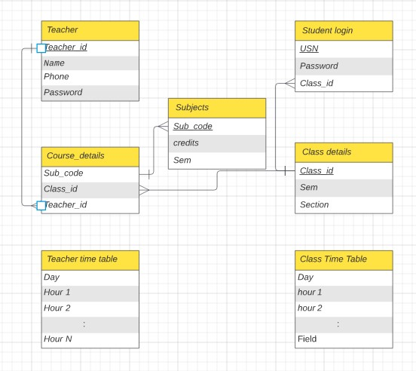

CHAPTER 5: IMPLEMENTATION

### Description of Database Tool and Backend

The backend of this project runs on Python programming language. Python is a high-level, interpreted programming language. Python is known for its simplicity, readability, and flexibility. It has a large standard library and an active community of developers. Python can be used for a wide range of projects, including web development, data analysis, and artificial intelligence. Python code is designed to be easy to read and understand, with a clear and consistent style. This makes it easier for developers to work together on projects and for new developers to learn the language. Its simplicity, flexibility, and readability make it a popular choice for beginners and experienced developers alike.

The Database used was MySQL, MySQL is an open-source relational database management system (RDBMS) that works with an operating system to implement a relational database in a computer's storage system, manages users, allows for network access and facilitates testing database integrity and creation of backups. It is most noted for its quick processing, proven reliability, ease and flexibility of use. It is a stable, reliable and powerful solution with advanced features like: Data Security, High Performance, complete workflow control, flexibility of open source.

The MySQL Database Software is a client/server system that consists of a multithreaded SQL server that supports different back ends, several different client programs and libraries, administrative tools, and a wide range of application programming interfaces (APIs). It also provides MySQL Server as an embedded multithreaded library that you can link into your application to get a smaller, faster, easier-to-manage standalone product.

In our project, we have used MySQL Connector to link Python to MySQL. MySQL Connector/Python is a driver that allows Python programs to connect to MySQL databases. It is written in pure Python and does not require any third-party library. MySQL Connector/Python supports a wide range of Python versions and platforms. It is licensed under the terms of the GPLv2, which makes it freely available for use in open source and commercial projects.

### Description of Implementation of Frontend

The user interface was designed using HTML and CSS. A part of the front end, mainly input interface consists of tkinter GUI. Several components like labels, textboxes, combo boxes, buttons etc. have been made use of.

Tkinter is a Python module that provides a wrapper around the Tk GUI toolkit. It is used to create graphical user interfaces (GUIs) in Python. Tkinter is included with standard Linux, Microsoft Windows, and Mac OS X installs of Python. Tkinter is relatively easy to use, and many examples can be found online to help beginners get started.

HTML is a markup language that is used to structure and organize content on the web. HTML consists of a series of elements that are used to define the structure and content of a web page. Elements are represented by tags, which are enclosed in angle brackets. CSS is a style sheet language that is used to describe the look and formatting of a document written in HTML. HTML and CSS are used together to create the layout, design, and style of web pages. CSS is used to control the look and formatting of a web page. It can be used to set colours, fonts, sizes, margins, and many other aspects of the page's layout and design. CSS can be applied to individual elements on a web page or to the entire page itself. HTML and CSS are essential technologies for building modern web pages and applications. Together, they provide the structure and styling that are needed to create engaging and interactive content for the web.

Flask was used to integrate the front end with Python. Flask is a web framework for Python that allows for easy creation of web applications. HTML can be integrated with Flask by creating templates and rendering them using the Jinja2 template engine. The HTML templates can be passed variables from the Flask application, allowing for dynamic content to be displayed on the website. This integration allows for the creation of powerful and dynamic web applications using the combination of Flask and HTML.

CHAPTER 6: TESTING

### Component Tests:

Component testing is undertaken when a module has been created and has successfully reviewed.

Each component of the software was tested individually from the adding subject names to adding teacher names and multiple other components were also tested.

### Add/Remove Teacher names:

|  |  |  |
| --- | --- | --- |
| TEST UNIT | TEST CASE | RESULT |
| Add teacher names | Click on tiles to perform search/ Add. | The entered name is added to teachers list |
| Add teacher names | Add empty names | An error message is displayed |
| Remove existing teachers | Click on delete tile after selecting teacher | The selected name is removed from list |
| Remove existing teachers | Click on delete tile without selecting teacher | An error message is displayed |

### System Test:

The whole system testing was done to evaluate the efficient working of software. All the bugs that were found were sorted out. Input Validation has been considered.

Our Project went through two levels of testing

### : Unit Testing

Unit Testing is a type of software testing where individual units or components of a software are tested. The purpose is to validate that each unit of the software code performs as expected. Unit Testing is done during the development (coding phase) of an application by the developers.

We tested individual screens and features before integrating everything together.

**6.2.1 Integration Testing**

Integration Testing is defined as a type of testing where software modules are integrated logically and tested as a group. A typical software project consists of multiple software modules, coded by different programmers. The purpose of this level of testing is to expose defects in the interaction between these software modules when they are integrated.

After unit testing, we tested the entire system as a whole, that included all the units.

CHAPTER 7: INTERPRETATION OF RESULTS

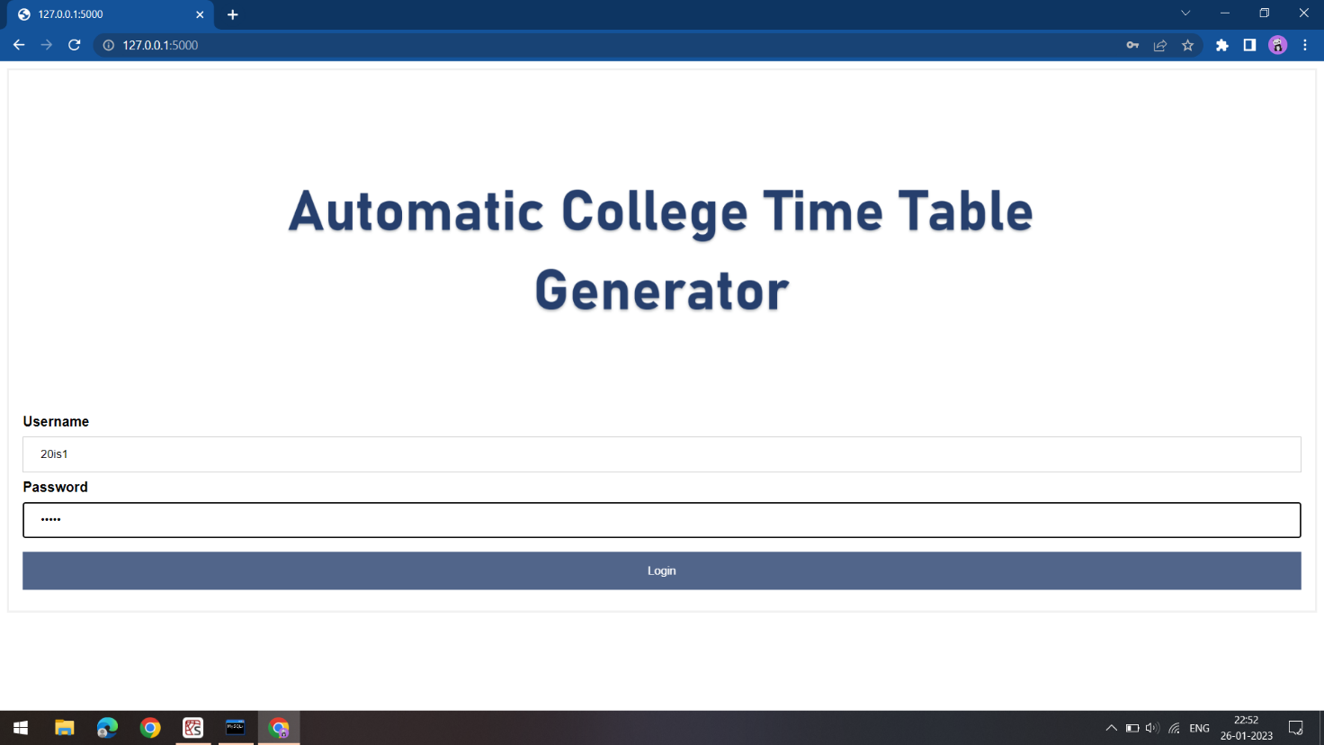

**Fig. 7.1:** Login Page

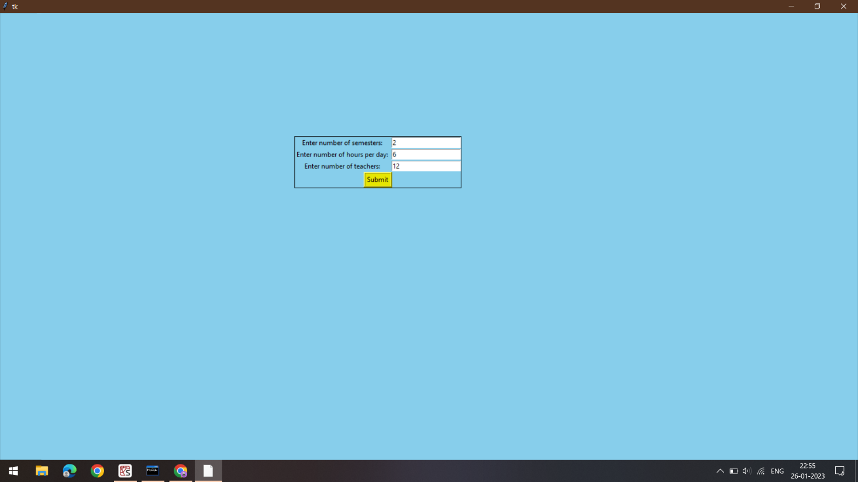

**Fig 7.2:** Admin Home Page

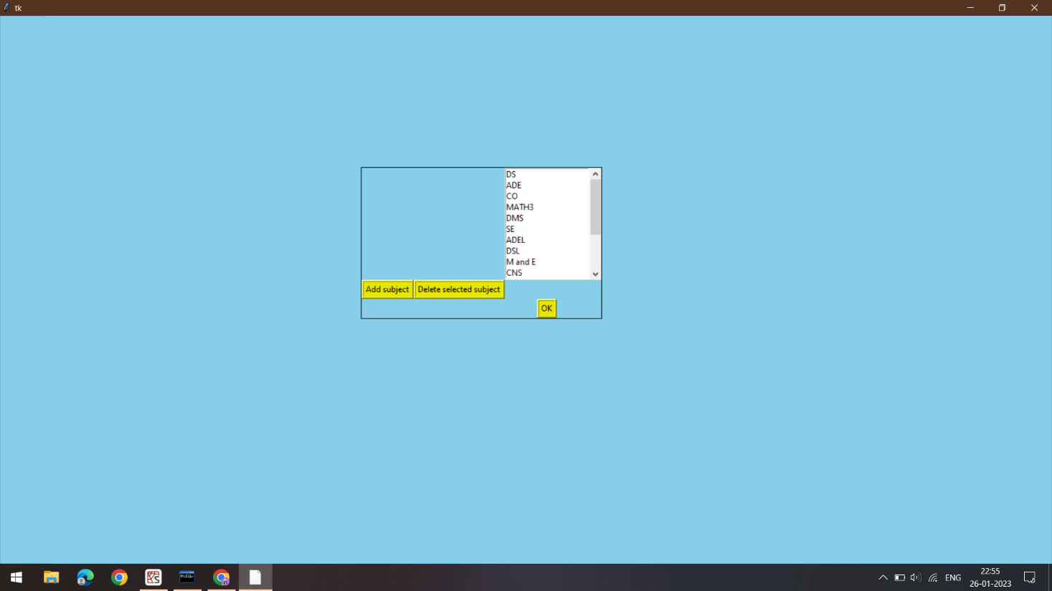

**Fig 7.3:** Subjects page

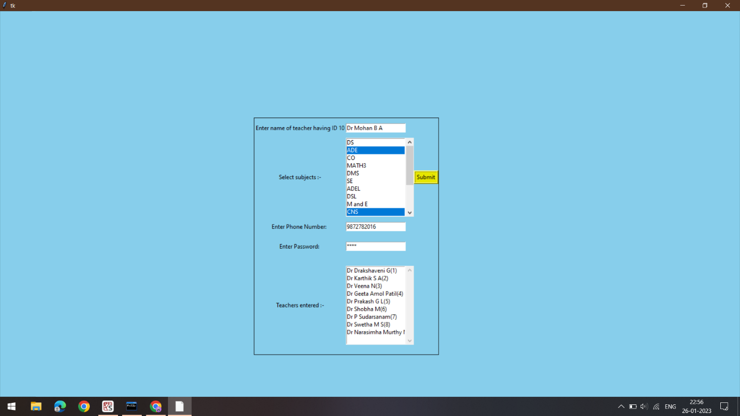

**Fig 7.4:** Teacher’s details page

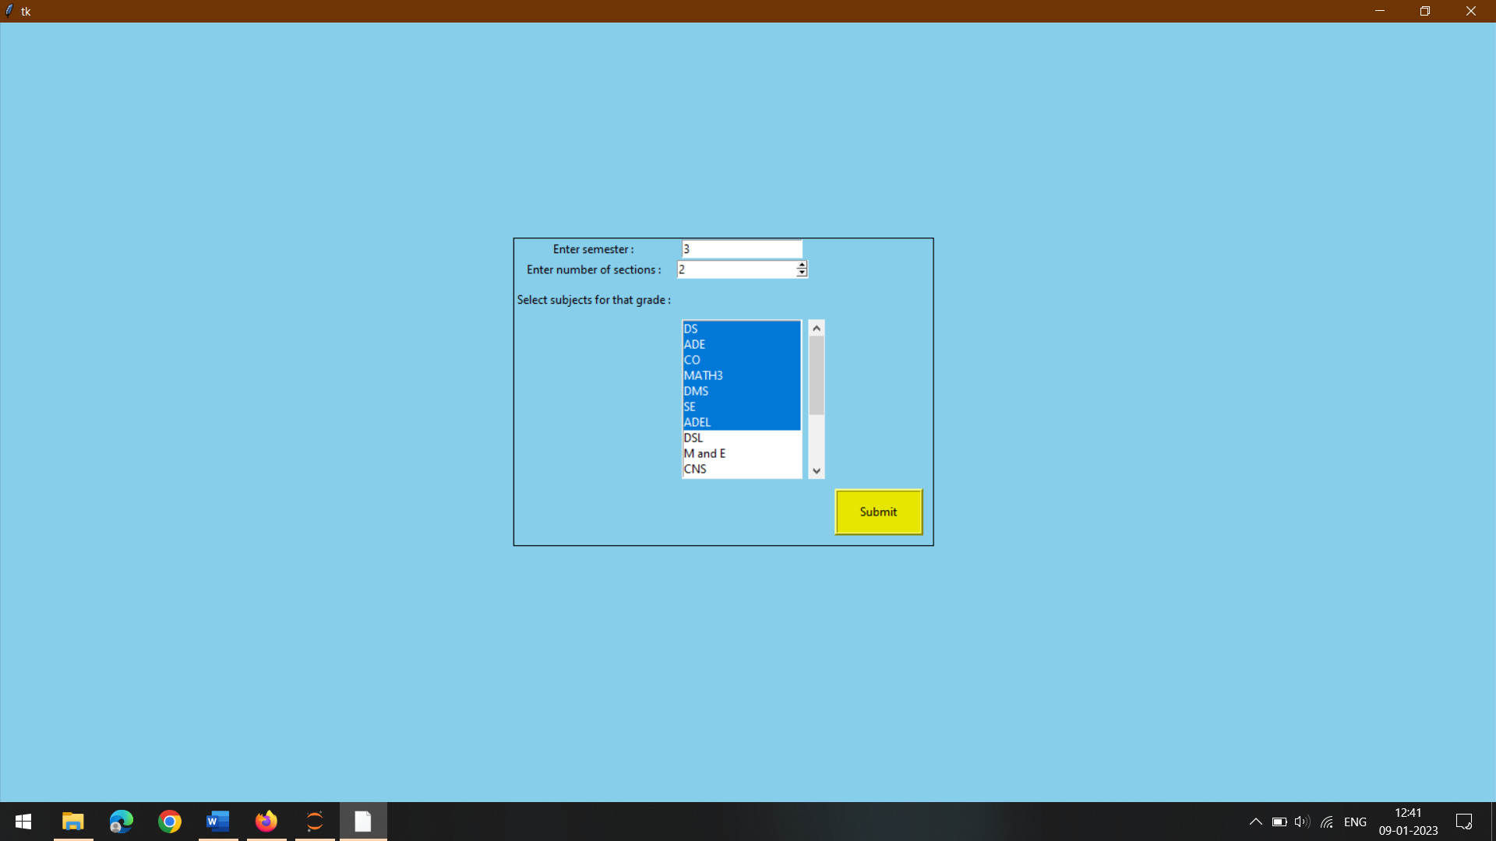

**Fig 7.5:** Select Subjects view

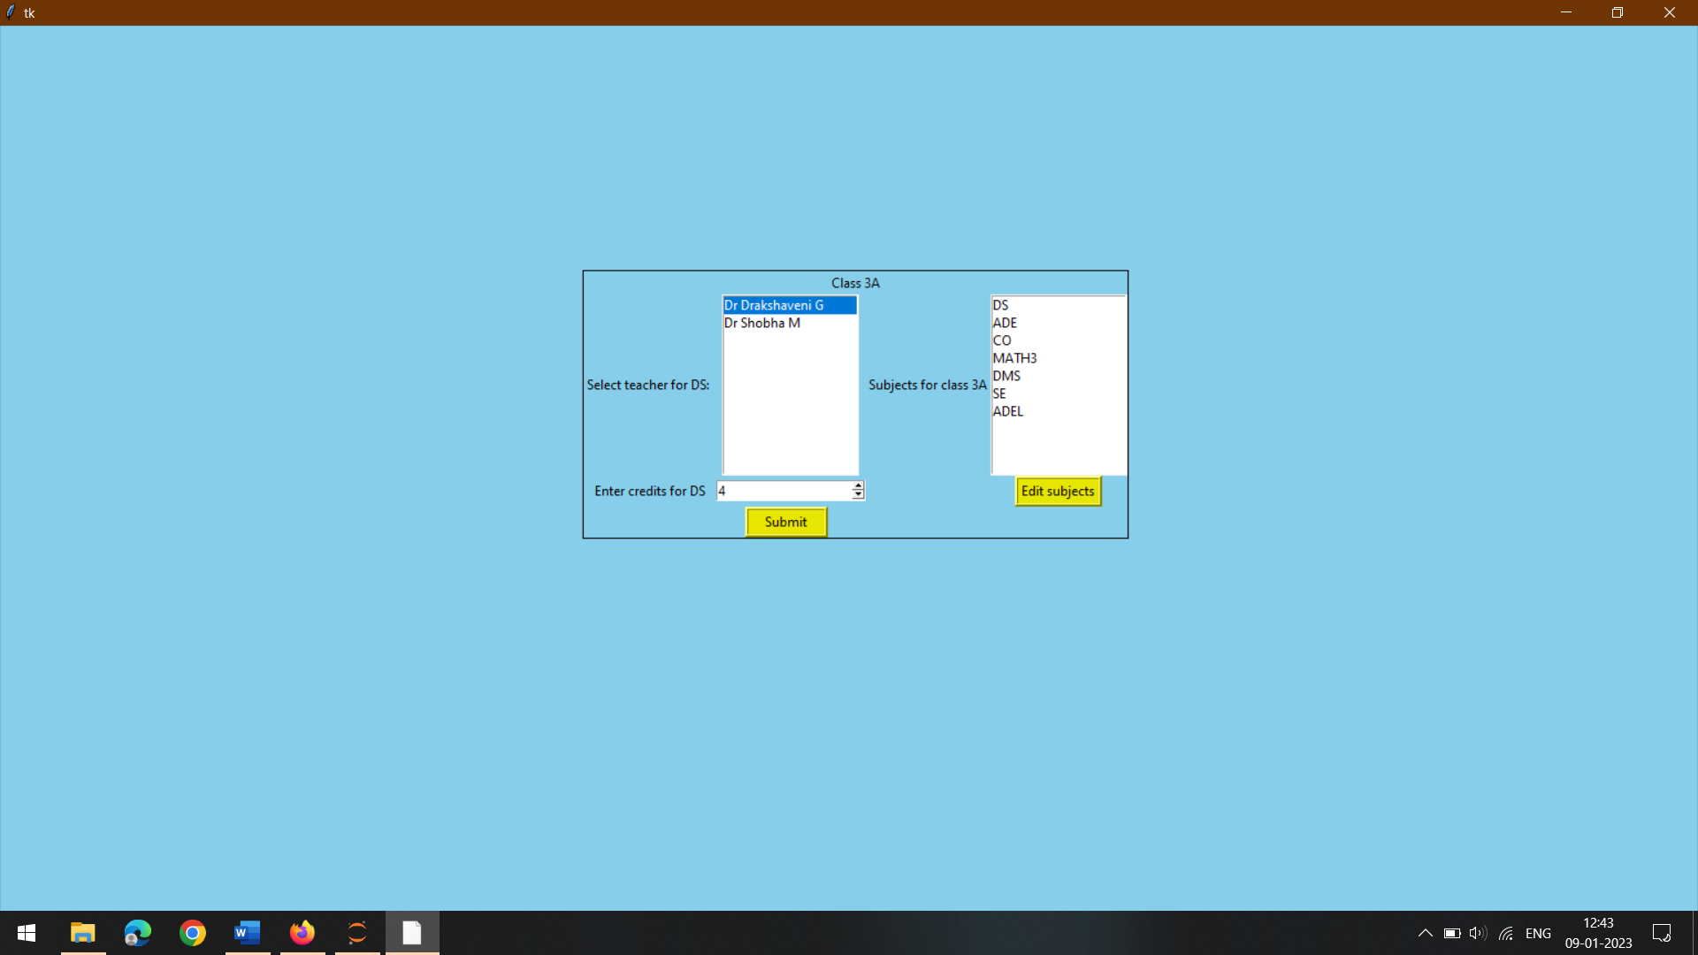

**Fig 7.6:** Screen to assign teachers to all classes

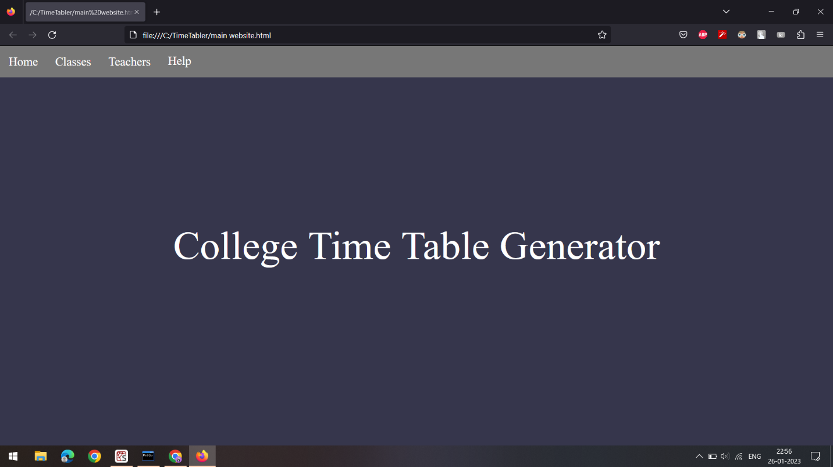

**Fig 7.7:** Output landing page

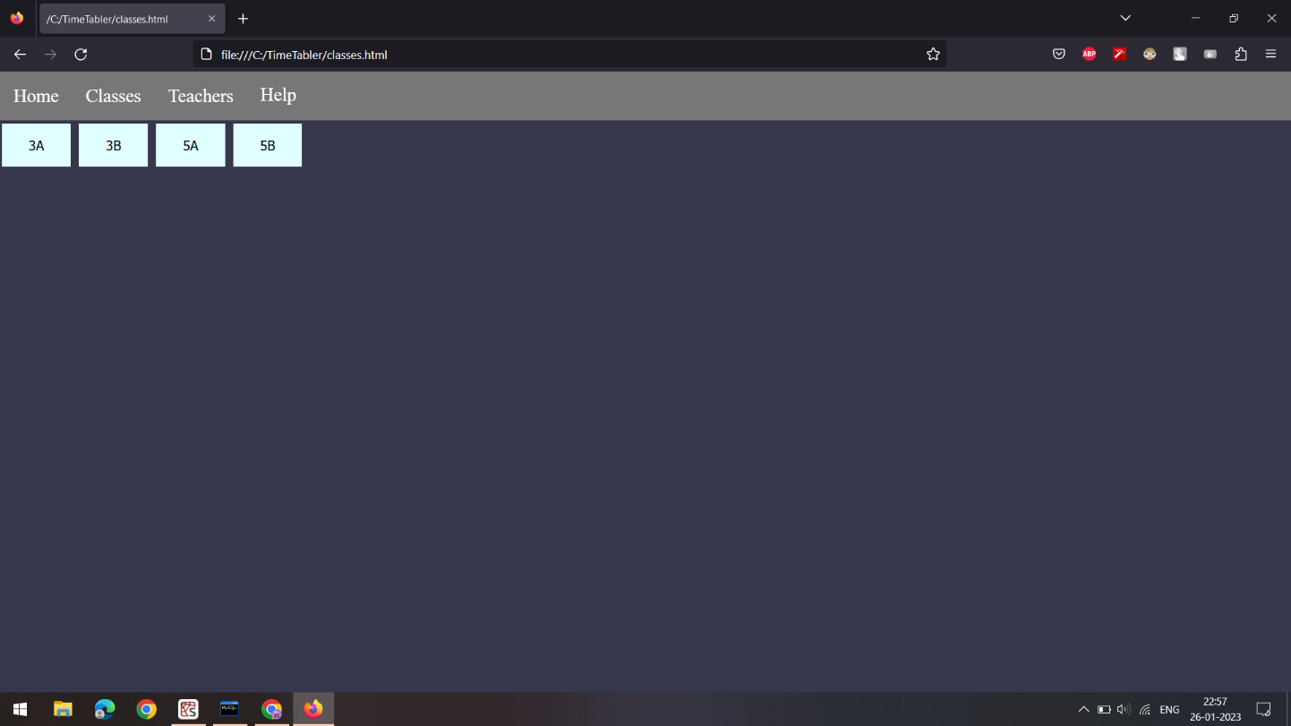

**Fig 7.8:** Page to view all class time tables

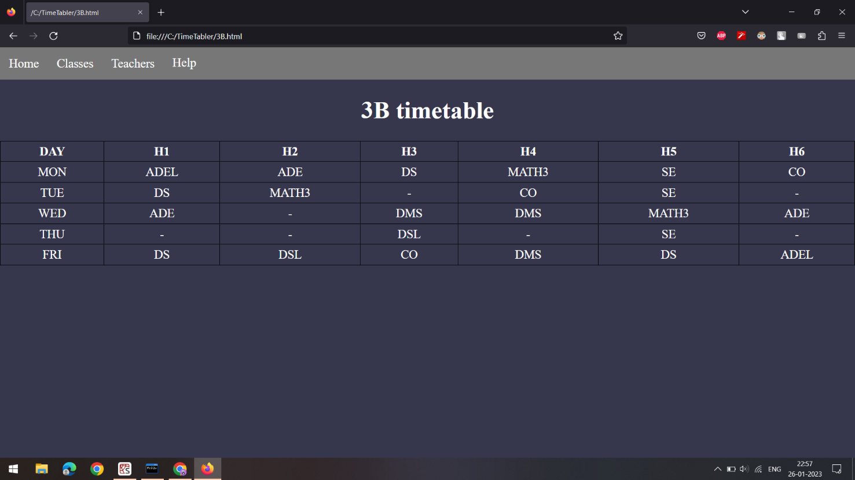

**Fig 7.9:** Class Time Table

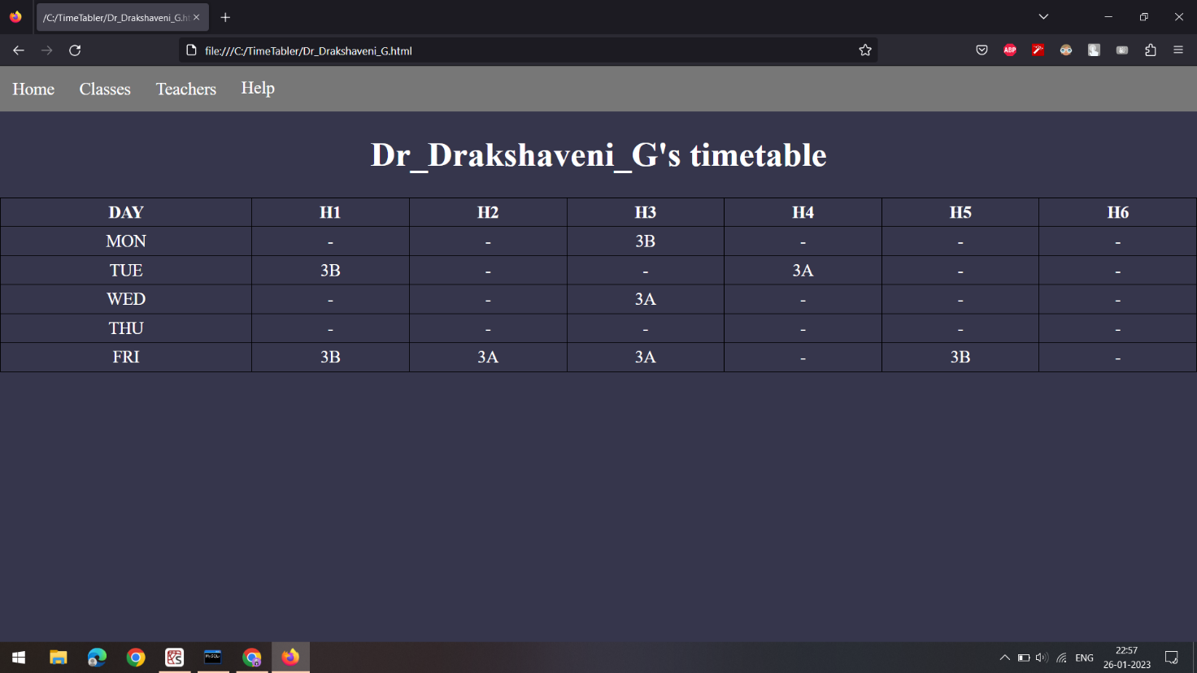

**Fig 7.10:** Teacher’s Time Table

CHAPTER 8: CONCLUSION

# The college time table generator project was a success in many ways. The program was able to generate a complete and accurate time table for the college in a short amount of time, which was a significant improvement over the manual process that was previously used. The user interface was intuitive and easy to use, which made it accessible to users of all skill levels.

# In addition, the time table generator was able to handle a wide range of inputs and constraints. It was able to consider the availability of classrooms, the schedules of professors, and the needs of different departments and programs. This made it possible to create a time table that was both practical and efficient.

# Overall, the time table generator was able to significantly streamline the process of creating a college time table and saved a significant amount of time and effort. It is recommended that the time table generator be implemented and used at the college on a regular basis to continue to improve the efficiency and effectiveness of the time table creation process.

# In future, this project could be improvised to not only allow even more input constraints, but it also can be modified to be made useful for other organizations that need to manage schedules, such as schools, businesses, and community centers.

CHAPTER 9: REFERENCES

* <https://www.tutorialspoint.com/python/python_gui_programming.htm>
* <https://www.geeksforgeeks.org/python-gui-tkinter/>
* <https://drive.google.com/file/d/1Txkrphrg0dZyLGcn_g8pVzp7HpruoEVA/view>
* <https://www.youtube.com/watch?v=l9niaFJh8Gs&list=PLWjCJDeWfDdfJ3cSUNe_XiUWGpJj1tEAr&index=3>
* <https://www.w3schools.com/html/>
* [https://www.tutorialspoint.com/index.htm flask/](https://www.tutorialspoint.com/index.htm%20flask/)
* Fundamentals of Database Systems, Ramez Elmasri and Shamkant B. Navathe, 7th Edition, 2017, Pearson.
* Database management systems, Ramakrishnan, and Gehrke, 3rd Edition, 2014, McGraw Hill.

DEPARTMENT VISION & MISSION

